PWA Tutorial 8 – register a service worker

<https://www.youtube.com/watch?v=6s697AJdlB8>

create in root , register it from another JS file

<https://developers.google.com/web/fundamentals/primers/service-workers/registration>

// link from index.html script and every other page

// check if browser supports service workers fist, check the navigator object

if("serviceWorker" in navigator){

    // yes browser supports so register service worker use register method,

    // this is an async task, returns a promise using .then promis syntax here

    // the promise says that at some point this will resolve or be rejected

    navigator.serviceWorker.register("/sw.js")

    .then(()*=>* console.log("service worker registered"))

    .catch(() *=>* console.log("service worker not registered"))

}

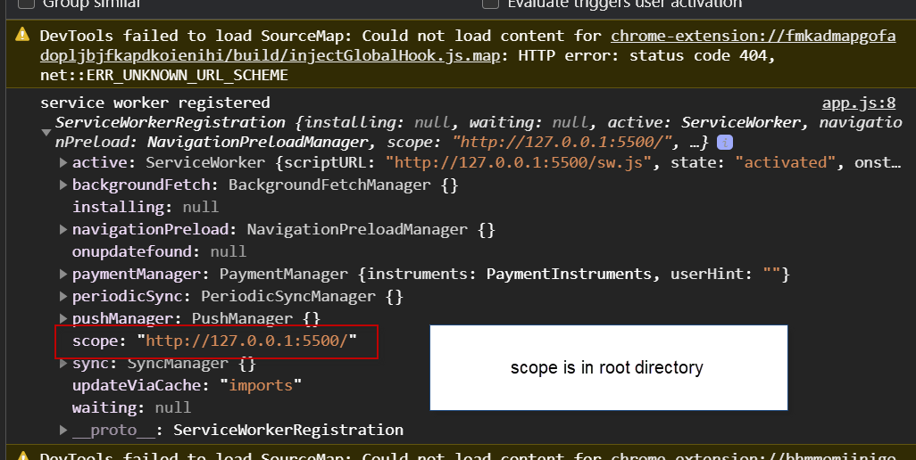

Can see the service worker registered in the application tab in dev tools

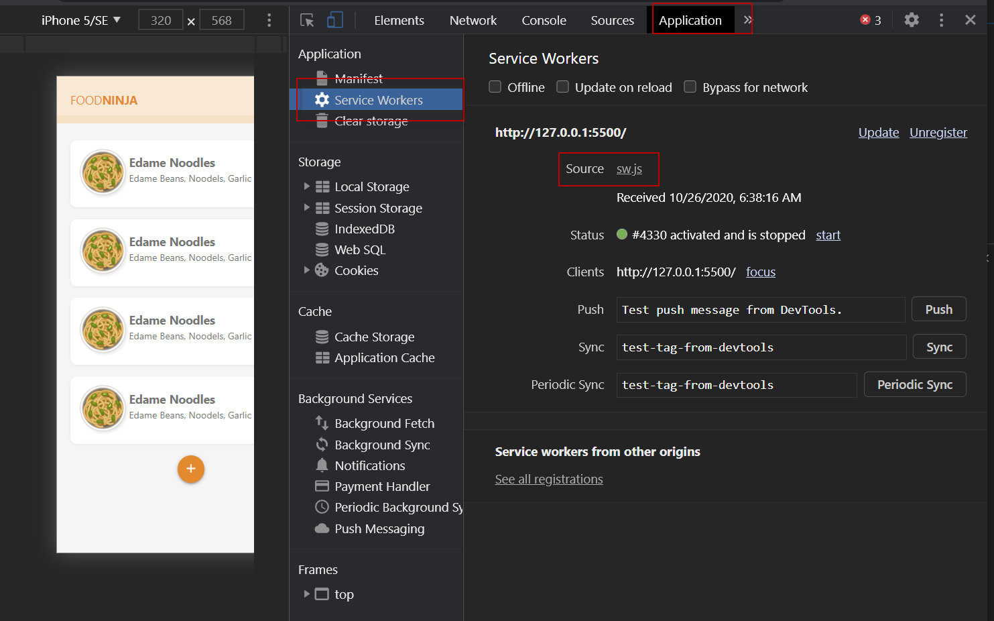

Service workers only work over https – secure connections